Project Survey Report Reference GTRESP1002 11 July 2023

Subject: Site Survey of CX400 Centrax SGT400 Gas Turbine Generator Package, Driven Unit and Associated systems.

End User Site: UNIGRA - Via Gardizza 9/B 48017 Conselice (RA) Italy

Report Prepared by : John Gamble _ Director Gas Turbine Resources Ltd

For the Attention Of :

Matteo Giora
Project Manager

per S.p.A.
www.gruppoper.com
Tel. +39 02 54.77.45.11
Mobile: 340 4765865
Mail: matteo.giora@gruppoper.com
Per-x@pec.it
Via Giovanni Antonio Amadeo, 59
20134 Milano
Ufficio di Mestre, Venezia

On behalf of End Customer: UNIGRA. Headquarter - Via Gardizza 9/B 48017 Conselice (RA) Italy

Introduction
The author arrived at Unigra Conselice plant on 5th July 2023 with the brief to complete a site survey of the installed CX400 Gas Turbine package with a view to assessing extent of damage and development of solution post a severe flooding event affecting the customer site during May 2023.

Following enquiries made directly with the end customer Unigra, GTR were advised by the company president that during the period immediately prior to the flooding event taking place, the CX400 gas turbine had been shut down, was completely cooled and its supply utilities, comprising both fluid and electrical services had been Isolated and de-powered 4 days before the flood event impacted the equipment**.
** This is a critical declaration and of utmost importance and the solution content proposed within this report is based entirely upon this description of events as they occurred in the period leading up to the flood event and therefore assumes that no hot gas turbine parts were quenched by water whilst in a hot state.
The duration of site survey visit was 3 days presence at Unigra Conselice plant.
During the site visit no attempt was made to rotate the gas turbine or associated power train.
Inspections completed were limited to external visual surveys of the machine and its systems and minor dismantling of piping systems, equipment access covers removal to view general condition. An internal optical inspection of the machine was completed on 7 July via established entry ports.

Detailed survey of the Unigra CX400 Equipment Purchase Contract, Maintenance agreement, Equipment Technical Manuals, Technical Drawings and Documentation, Spare Parts Stock and Special Maintenance Tooling was not completed during the visit. Identification of this key information and special engine handling tooling resources remains an essential task if recovery of the equipment is to be undertaken.

Observations

2.0 General
Upon arrival the CX400 was found in isolated de-powered and generally clean condition, presumably having been cleaned externally previously by site recovery contractor. The peak flood water level had been marked at various points on the equipment. Multiple devices that were considered as being below the flood water level had been removed from the turbine control system for specialist cleaning and recovery attempt. Identification tags were in place where equipment have been removed and it appears this work had been correctly controlled. An inventory was taken of all control parts removed and subject to cleaning for potential recovery.
A comprehensive inspection of the gas turbine package showed that no dismantling of the turbine package fluid systems or control devices had taken place and all systems were intact.
In some cases skid electrical junction boxes had been disturbed presumably to facilitate cleaning by site recovery contractor . Completion of this work remains outstanding as several junction boxes were noted to be in dirty condition and still to cleaned be dried.
The operating history of the gas turbine shows accumulated operating hours to be 8764 with 93 starts recorded per below control system devices

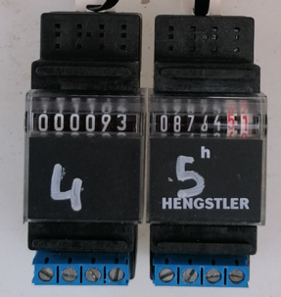 Fig 1 Turbine operating hours and starts

The gas turbine equipment is of recent supply and based upon the engine data plates estimated year of equipment commissioning date would be estimated as 2021.

2.1 Gas Turbine Systems inspections
2.1.1 Turbine Casing Liquid Drains
The CX400 gas turbine package is fitted with a turbine compressor wash system designed to clean the engine compressor by injection of a water and detergent mixture via the engine intake. Generally this washing process may be completed both on-line and off- line when the engine is cool. As integral to the wash system installation fluid drains are installed to all low points of the turbine casings to permit draining of accumulated liquids resulting from water injection during the offline wash process.

In the CX400 Centrax package engine drain lines are connected to a common drain manifold and control drain block valve installed adjacent to the installed wash drain tank.
During the visit all fluid drain lines were physically disconnected from the engine to assess presence of water , an image record is shown below.

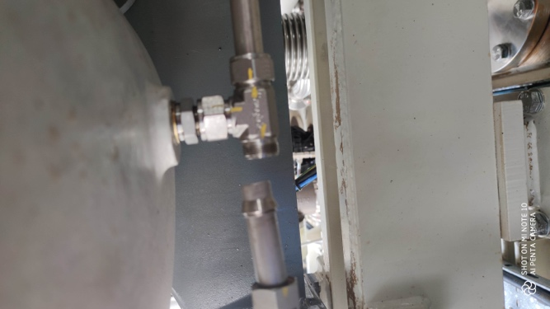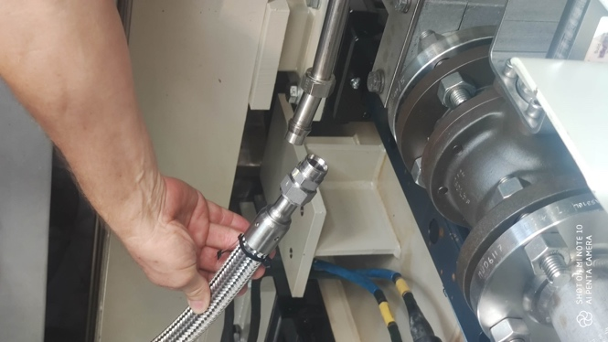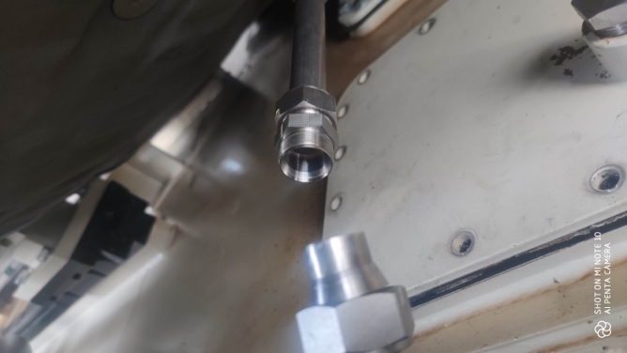

Fig 2 Intake Volute Drain Fig 3 Interduct Casing Drain. Fig 4 Turbine Exhaust Volute Drain

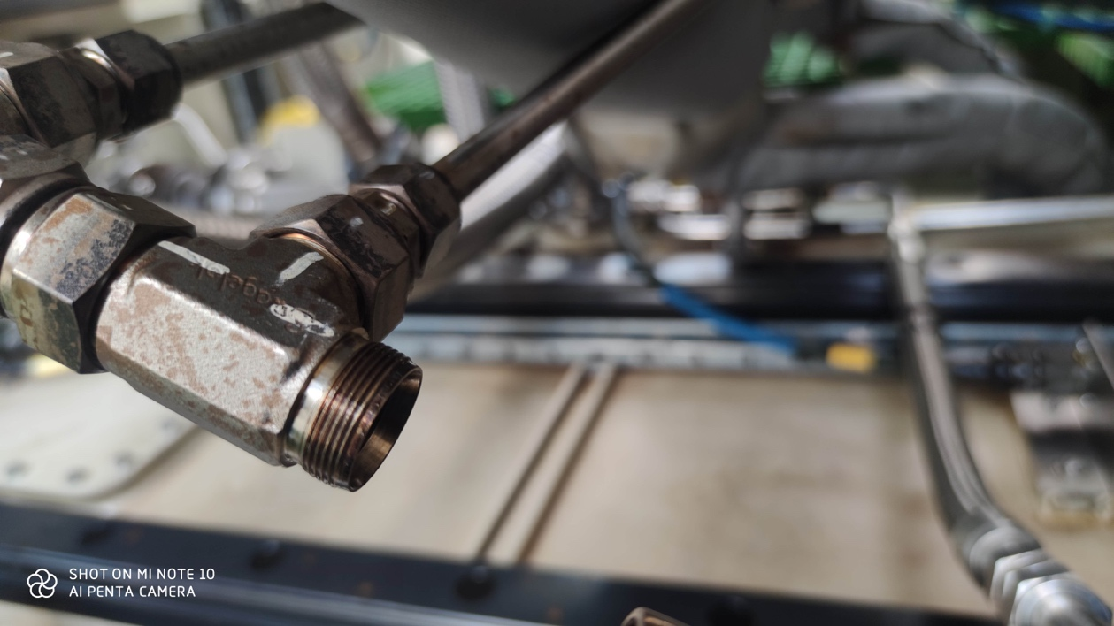

Fig 5 Combustion chamber 4 & 3 Casing Drain

Observations.
Fig 2 Intake Volute Drain – Dry with no evidence of water or contamination presence
Fig 3 Interduct Casing Drain - Dry with no evidence of water or contamination presence
Fig 4 Interduct Casing Drain - Dry with no evidence of water or contamination presence
Fig 5 Combustion chamber 4 & 3 Casing Drain - Dry with no evidence of water or contamination presence

These findings infer no water has entered the gas turbine air and hot gas washed casings at these positions. To confirm this an internal optical inspection of each casing was also completed, in each case no evidence of water presence or contamination was visible in the engine casings listed above.

2.1.2 Turbine Auxiliary Gearbox
The CX400 gas turbine package is fitted with an auxiliary gearbox of Peter Brotherhood Manufacture to provide for engine starting and pump power take off applications. This gear box was accessed for internal inspection via its access covers installed. An image record of findings is shown below.
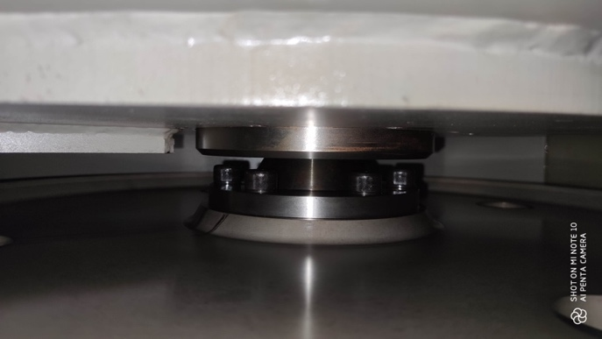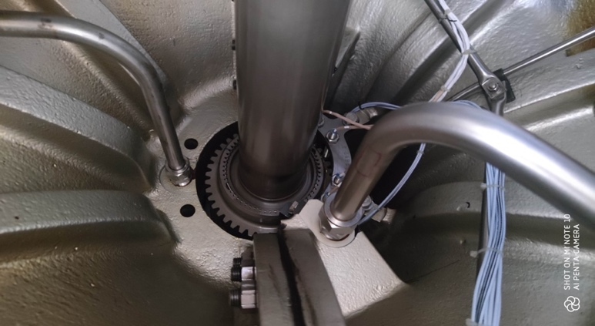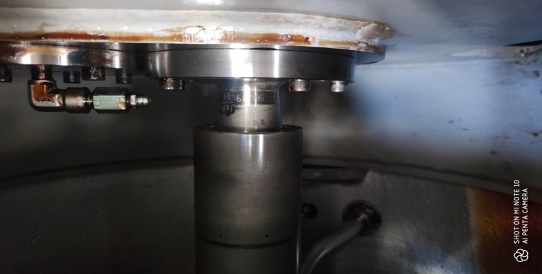
Fig 6 Auxiliary Gearbox Internal View Fig 7 GT to Aux GB Drive Coupling. Fig 8 Auxiliary Gearbox Internal View

The above images are consistent with findings recorded internal visual inspection completed during April assumed to be before the flooding event (below) , in both cases parts noted in good clean condition.

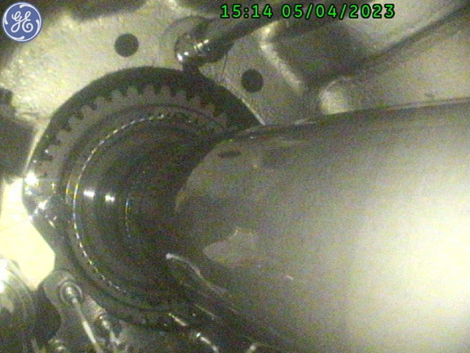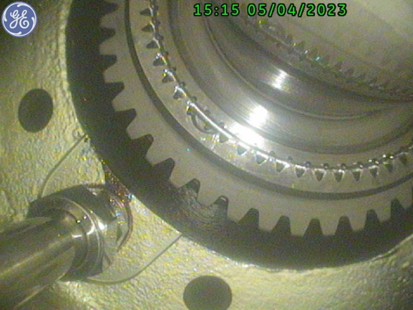
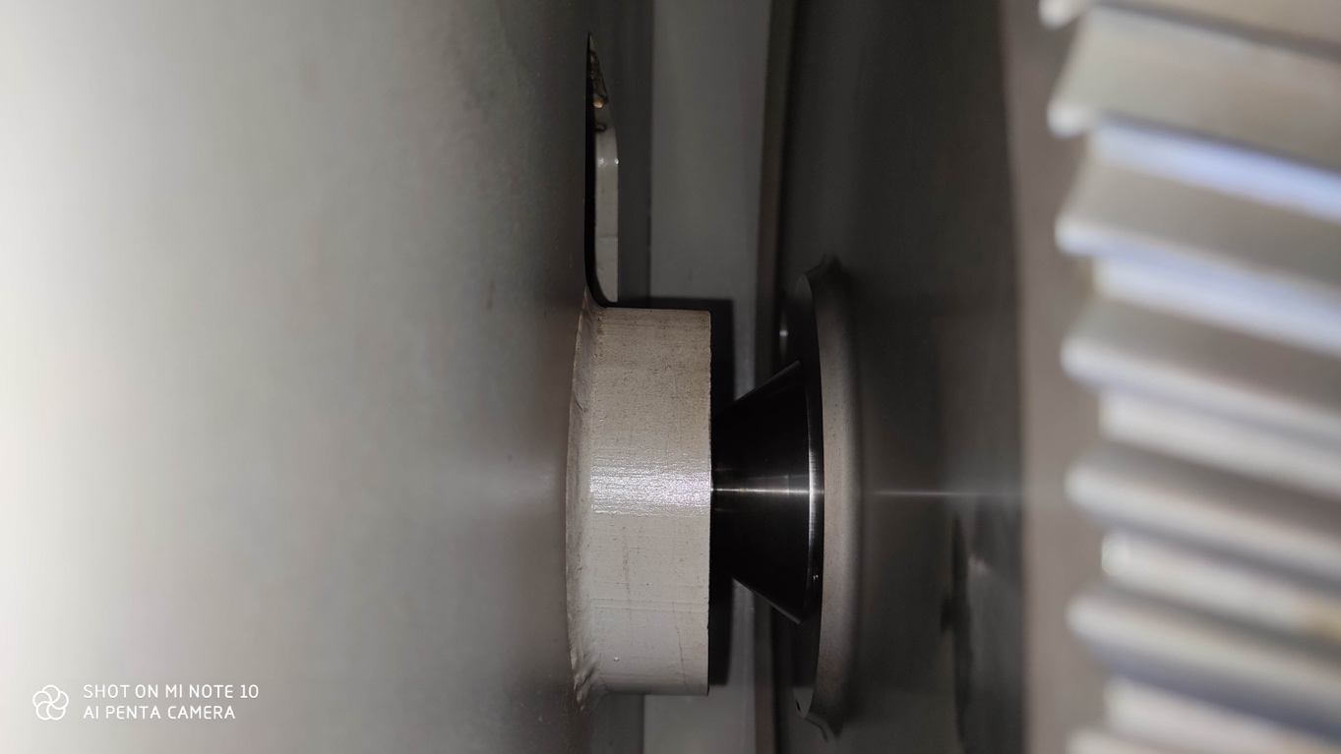
Fig 9 Auxiliary Gearbox Internal View drive gear and shaft
The internal images of the gearbox show the unit to be in good clean condition with no evidence of water ingress, contamination or damage. Return to service without intervention is anticipated.
2.1.3 Turbine Main Speed Reduction Gearbox
The CX400 gas turbine package is fitted with a main speed reduction gearbox of Allen Gear Manufacture to provide for engine power transmission to alternator at 1500rpm. This gear box was accessed for internal inspection via its breather system using 6mm flexi-scope.
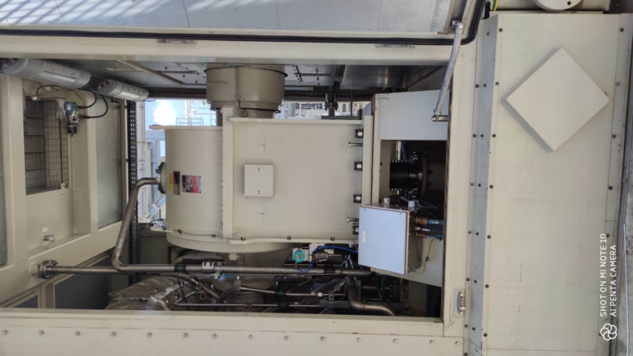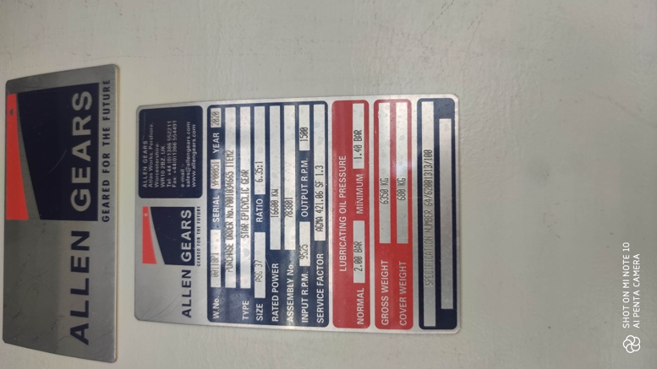
Fig 10 Main Gearbox External View Fig 11 GT to Aux GB Drive Coupling.
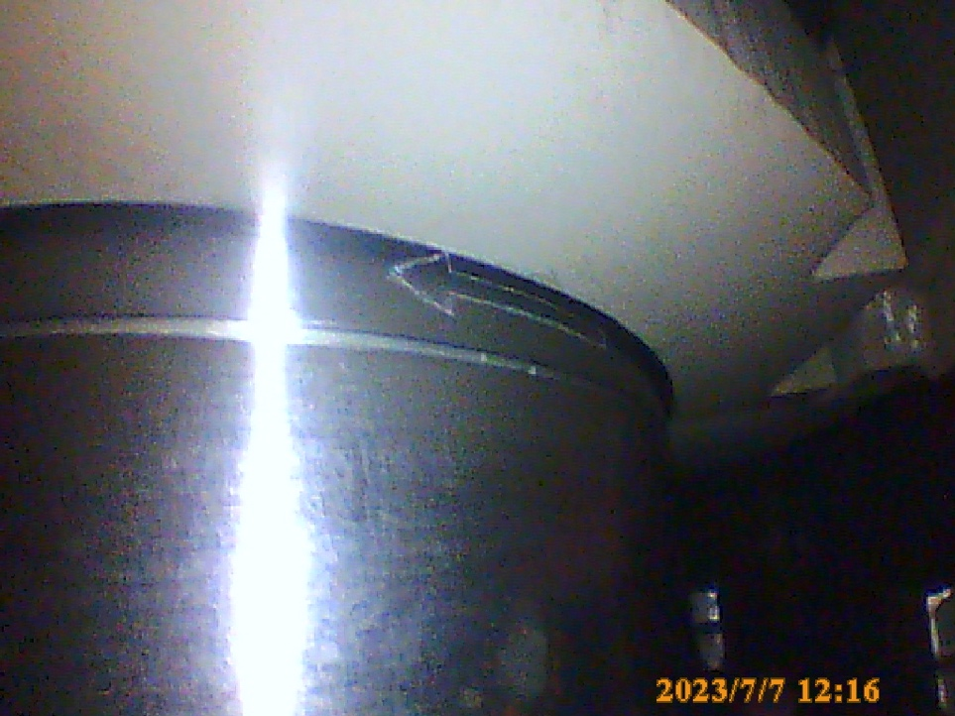
Fig 12 Main Gearbox Internal View Gear Output Shaft and Thrust bearing face

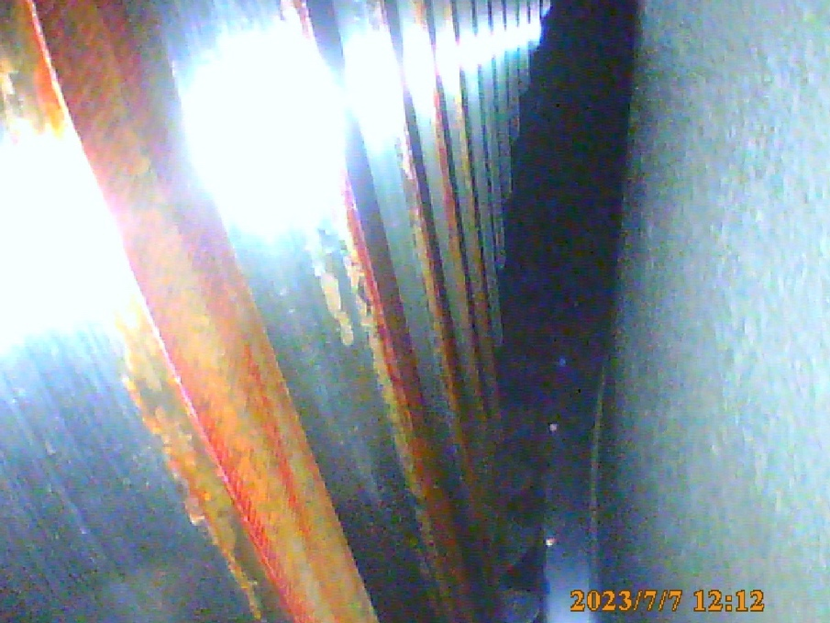
Fig 13 Main Gearbox Internal View – Reduction planet gear inside epicyclic cluster showing light surface corrosion

The internal inspection of the gearbox casing base showed no evidence of water, debris or contamination presence, the casing was found in clean condition externally and internally. Some evidence of minor surface corrosion residue was present on some gear teeth ( Fig 13) , this is assumed to be due to increased humidity inside the casing and gearbox oil drain. In summary, the gear was noted to be in satisfactory condition however an integrity check for inspection of shaft journals and main bearings is recommended to confirm
condition and suitability for return to service. Post- inspection a return to service of the existing gear unit is anticipated.

2.1.4 Driven Unit Alternator
The CX400 gas turbine package is fitted with an alternator of GE Power Conversion Rugby UK Manufacture. The alternator was inspected externally and internally using 6mm flexi-scope. The internal areas of the alternator casing base were found in clean and dry condition with no evidence of water ingress or contamination. The stator and exciter windings also appear in clean condition.
For expediency, we would recommend activation of the alternator internal heaters and completion of both rotor and stator electrical insulation testing by an established reputable Italian alternator servicing company to be witnessed by the selected turbine recovery project management team.
An inspection of the alternator cooler intake filtration media was completed during the survey, replacement of the MANN HUMMEL filter elements is recommended as it appears they are of original supply and have not been subject prior replacement or normal scheduled maintenance to date. This filter replacement is included in the turbine “A” inspection schedule due at 9000 operating hours

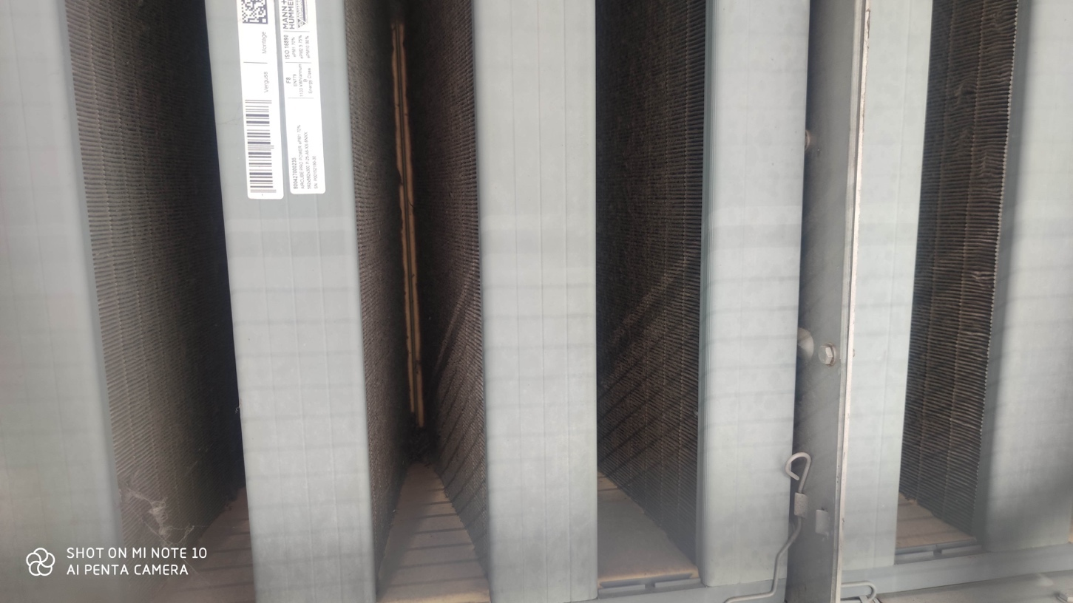
Fig 14 – MANN HUMMEL Alternator Cooler Filter Media requiring replacement

Additional cleaning is required to alternator cabling connection junction boxes where contamination and water remain present , refer to images overleaf.

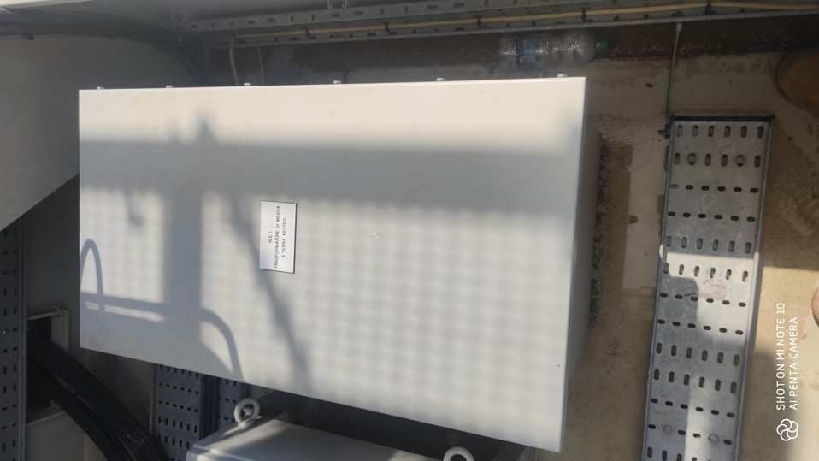
Fig 15- Neutral Earth equipment requiring cleaning and testing attention
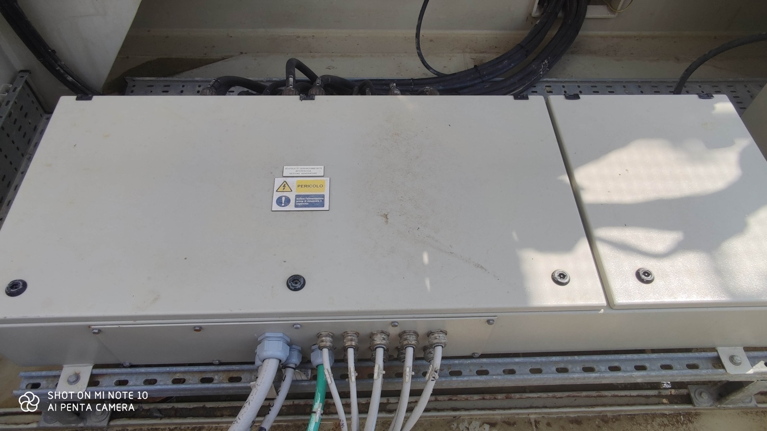Fig 16 - Alternator connection junction boxes requiring cleaning and integrity checks
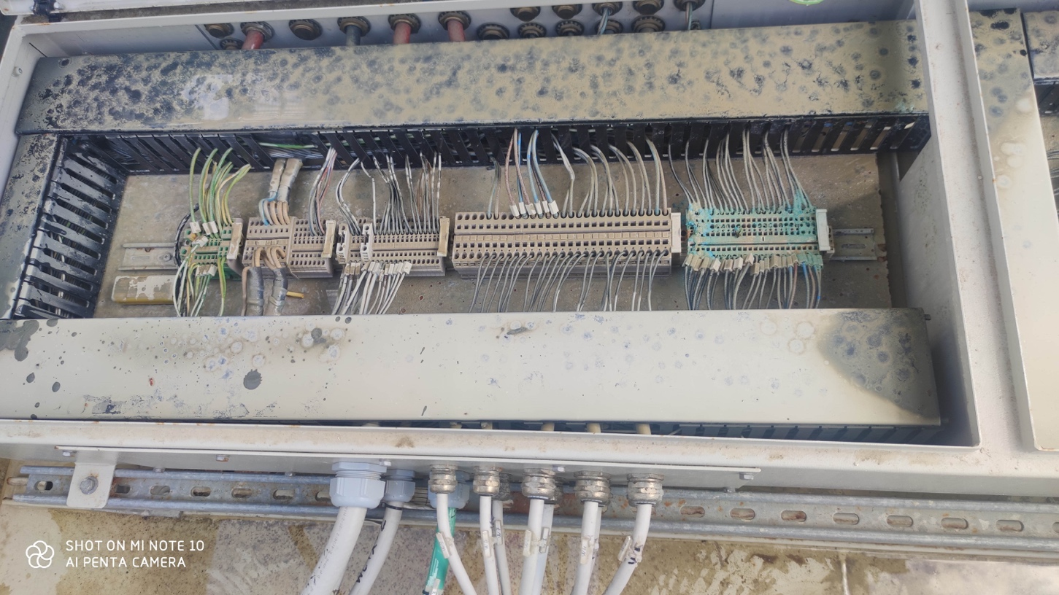
Fig 17 - Alternator connection junction boxes requiring cleaning and integrity checks

2.1.4 Turbine Control System

The Gas turbine package control system was inspected in detail and a comprehensive photographic record was compiled recording details of all components installed to the control system in as found condition. In addition an inventory of all components already removed for cleaning by site contractor was compiled.
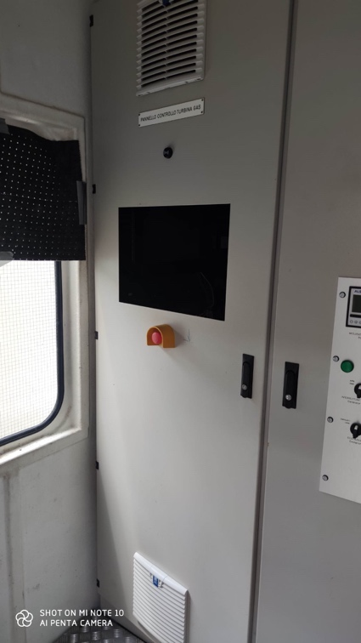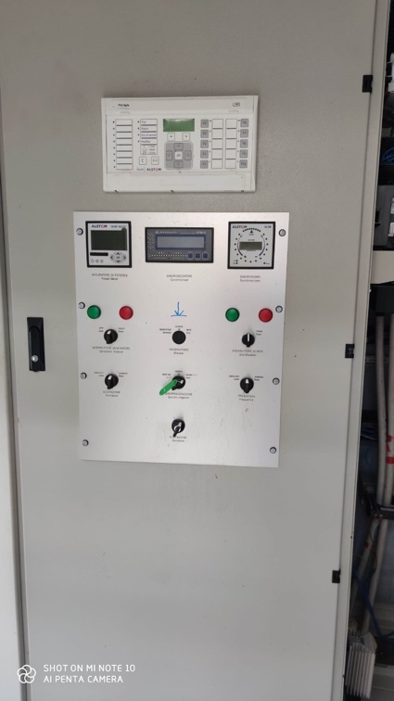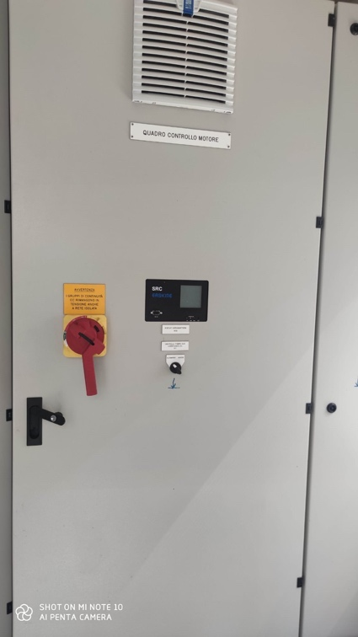
Fig 17 Turbine Control and MCC panel Facia

Approximately 40% of the control system internal components have been submerged in flood water, the affected components have been removed for cleaning on site. As integral to this cleaning and attempted recovery process correct further attention needs to be given to function testing of the removed components prior to considering their re-use.

For smaller lower cost components such as MTL isolation barriers the most cost effective and expedient route recommended would be direct replacement with new parts. For higher value parts we would recommend a formal testing program to confirm full functionality. Component testing is a service available within our company portfolio of services.

A recovery of the existing turbine control system is considered as a practicable solution utilising controls personnel with the necessary level of experience and expertise with the SGT400.

With this objective in mind the next step would be to undertake a more detailed survey of the control systems installed.

In the first instance it would be necessary to check if all the panel equipment is working, this would involve: -

- Isolation of field wiring in case of earth faults
- Checking for panel earth faults
- Powering up each circuit individually
- Checking operation of panel equipment
- Checking PLC software configuration
- Checking software configuration of other components, vibration, overspeed etc

An estimate for this work would be 8 days attendance on site by controls engineer.

To achieve the necessary testing panel power supplies would be required.

Additional consideration would need to be given to all field instrumentation and cabling, if there is water ingress into the cables, this could identify a larger problem. However being a gas installation the cables should be sealed in the majority of cases.

2.1.5 Turbine Package Fire and Gas Protection System

The CX400 gas turbine package fire and gas protection system utilises an MX FMZ500 control panel having internal battery back-up system. The FMZ500 control system was inspected in detail and comprehensive photographic record was compiled showing details of the F&G control system and individual control system components in as found condition. The recorded images were submitted to the control system manufacturer during our survey visit (Refer to images overleaf Fig 18). As this control panel requires fire system certification any repair would need to comply with set EN guidelines.

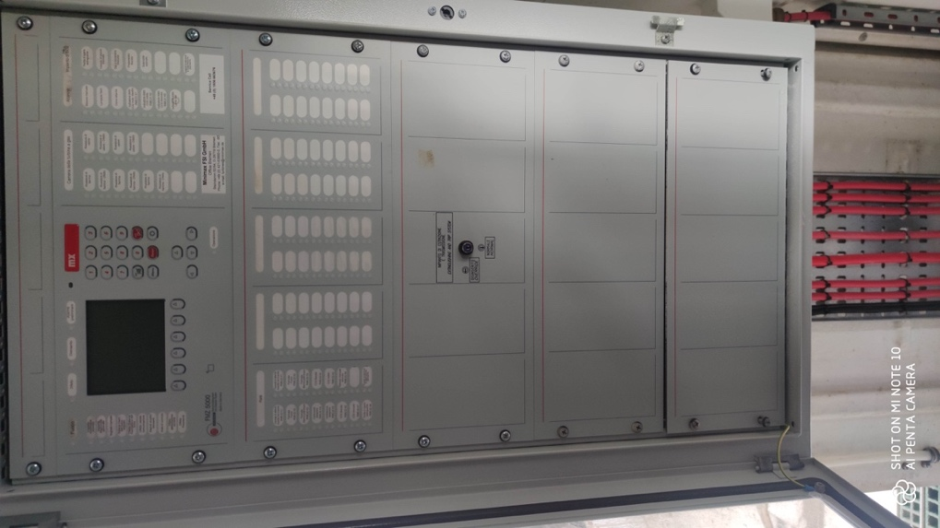 Fig 18 MXFMZ5000 Fire & Gas Protection Panel Facia

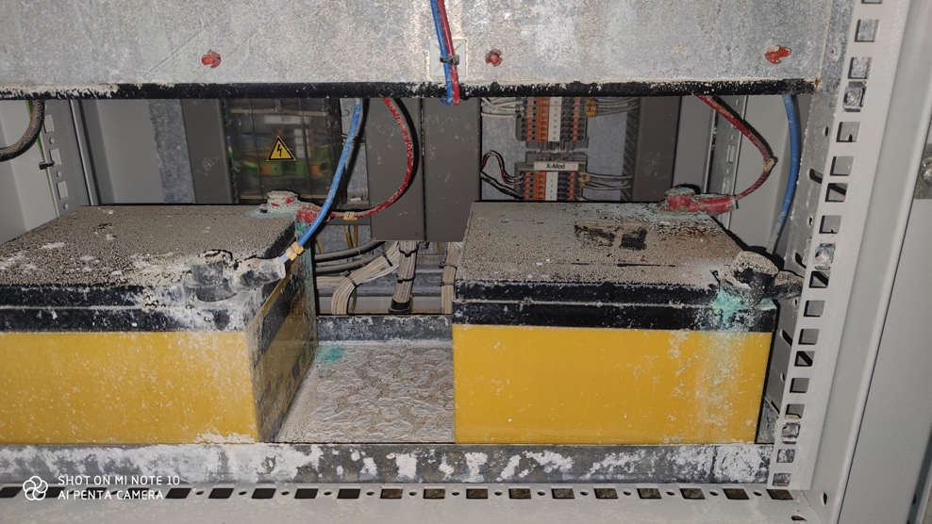
Fig 19 FCZ500 Panel Base Internals As Found

The FMZ500 control panel was found in poor condition, this panel has battery backup systems and full replacement with new is the recommended and likely route toward a solution. Our initial recommendation is to mobilise personnel from the manufacturer to complete a detailed survey of the entire fire and gas installation as a standalone system. Survey would take into account all field devices installed, their integrity, cabling integrity and to identify in detail the full requirement for system solution development.

It would be our expectation that fire and gas system field sensors and devices would be retained in most cases and equipment replacement necessary would be limited to the FMZ500 control panel only. The manufacturer was contacted directly during our Unigra site attendance, the manufacturer commented that technical personnel would be available immediately and that they have sufficient stock material to provide a timely solution for this control panel.

    - Turbine Package Lubrication Oil System
During survey the gas turbine lubricating oil tank was accessed at 4 positions via removal of a selection of the tank access hatches installed. The oil fill had been removed and viewing the residue inside the tank base it was apparent that some water and debris has entered the oil tank and that surface corrosion is starting to occur at the tank base per Fig 20 below. The FMZ5000 will become obsolete at the end 2023 current replacement for this panel is the FMZ6000.

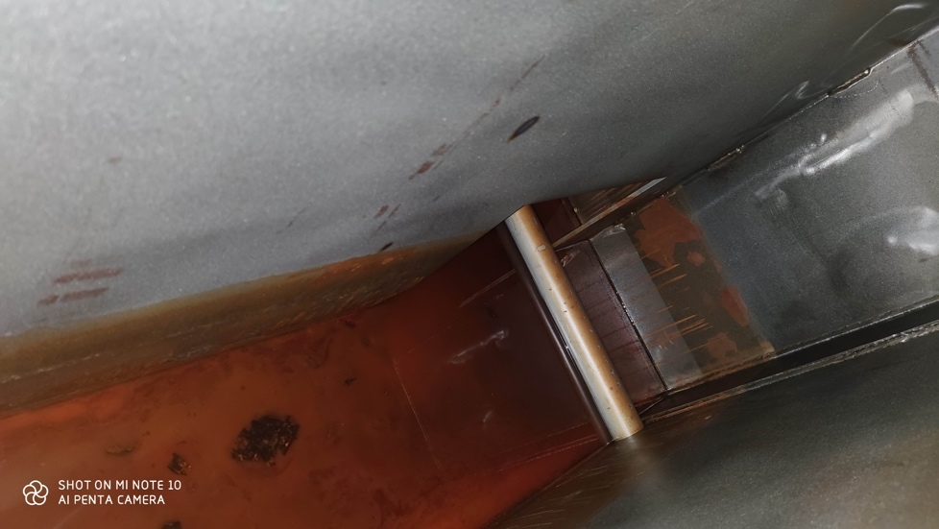 Fig 20 Sample of oil tank base

Comprehensive cleaning of the oil tank will be necessary by accessing all areas of the tank compartments individually for cleaning and chemical corrosion treatment. As the tank is large with multiple internal compartments this work would be best completed with the gas generator removed from the package and with all access plates and oil pumps removed. Cleanliness of the oil tank is required to a high standard.

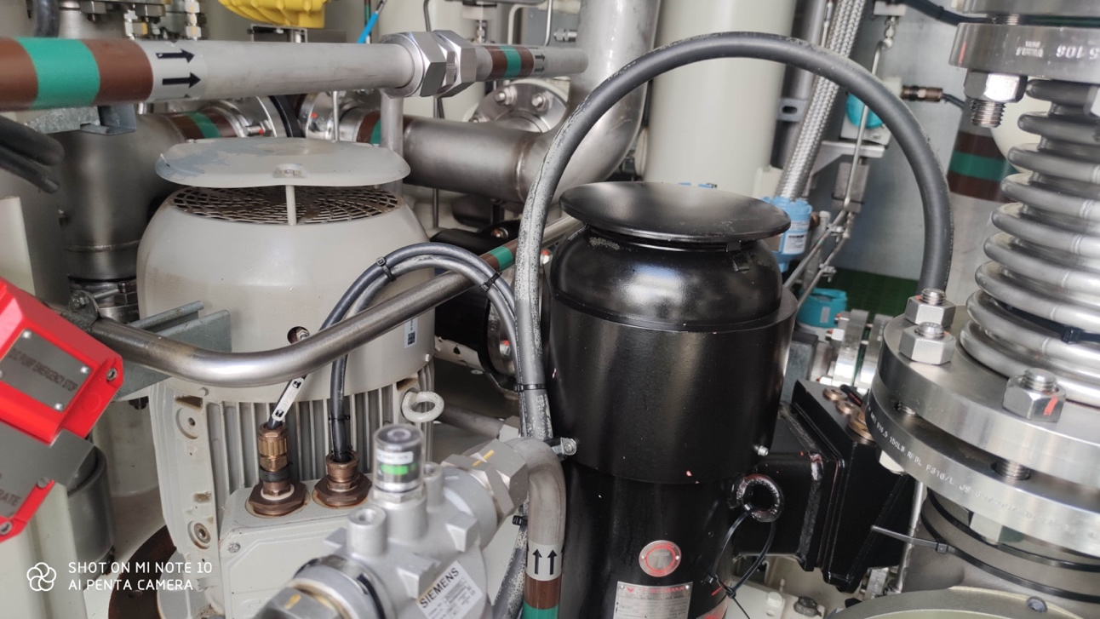
Fig 21 Motor Driven Auxiliary and DC Emergency oil pump installation

The auxiliary oil pump and DC emergency oil pump motors have been submerged below water during the flood event, these motors should be removed and sent to motor service contractor for review. Upon completion of oil system cleaning , flushing operations will be necessary prior to connection of oil feed lines to gas turbine. It is currently assumed that the customer has stocks of serviceable consumable lubrication oil filers available on site as several would be required to support oil system flushing operations. The turbine lubrication oil cooler located on the roof of the gas turbine package requires scheduled maintenance as the filer media matrix is obstructed see Fig 21 below.

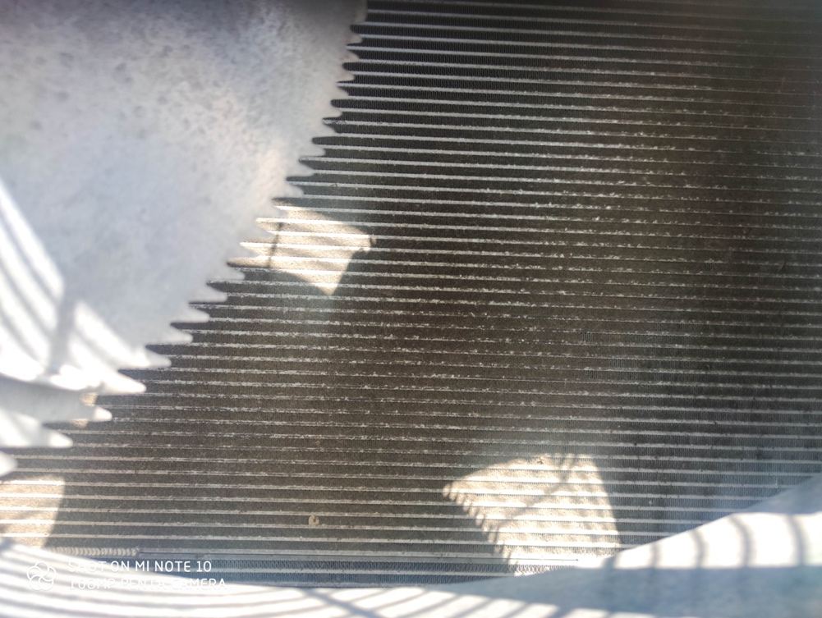
Fig 22 Oil Cooler Matrix obstructed

    - Turbine Package Gas Fuel System
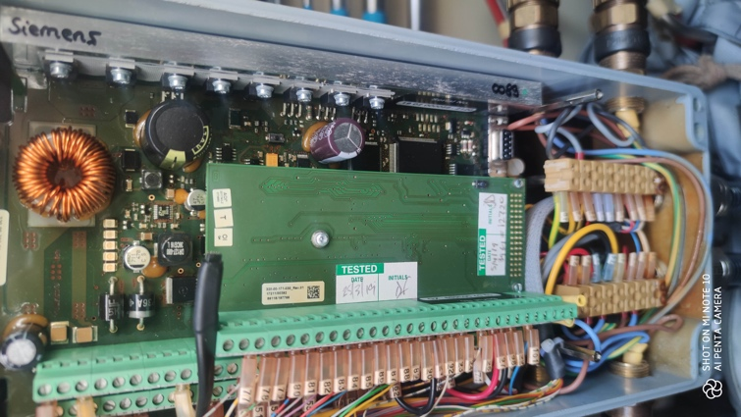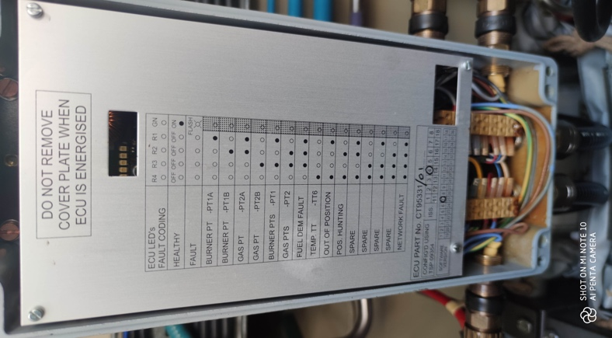
Fig 23 DLE Fuel Valve Controller

The pilot and main gas fuel control valve junction boxes were accessed in both cases. The Abtech junction boxes in use show evidence of water ingress and the valve control boards may be damaged as a result. These valve may be function tested during control system survey recommended however as these valves have specific Siemens content, replacement spare parts purchase is recommended for these valves to ensure a contingency stock is available at site should these be required. Siemens Part number for ordering is CT95331/01 quantity 2.

3.0 Gas Turbine Core Engine Serial No MW441
3.1 Gas Generator
It is understood that the gas turbine engine serial number MW441 was subject to an internal optical inspection during April 2023 and that the internal findings were normal for a machine that has operated to 8764 hours.
At these operating hours a scheduled general package maintenance “A” inspection is also due and this routine “A” inspection should form a part of any equipment recovery attempt to ensure all systems are in good order. At present, attention is required to package systems not affected by flooding.
The internal visual inspection images available with the customer generally show the air and hot gas stream areas of the machine which generally presents in clean condition. There is some cracking evident at Gas Pilot burners however this is not uncommon for SGT400 pilot burner for which there are crack acceptance criteria existing.
During the GTR survey site visit, no fluids were found in the internal air/ gas path casings , our focus was also expanded to the lubrication oil side of the machine, in particular the most highly loaded bearing , the compressor turbine bearing position 2 that was viewed in close proximity to the engine rotor shaft. The resultant images are shown below.
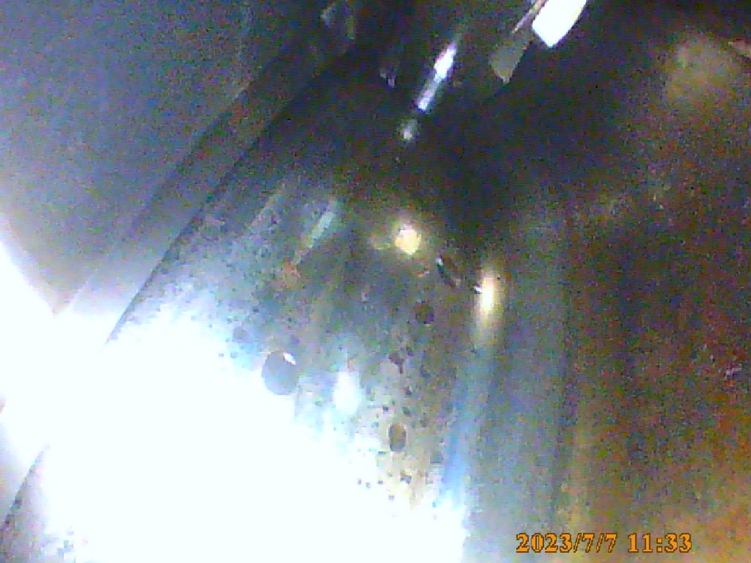
Fig 24 Rotor shaft at CT bearing position adjacent to vibration sensor
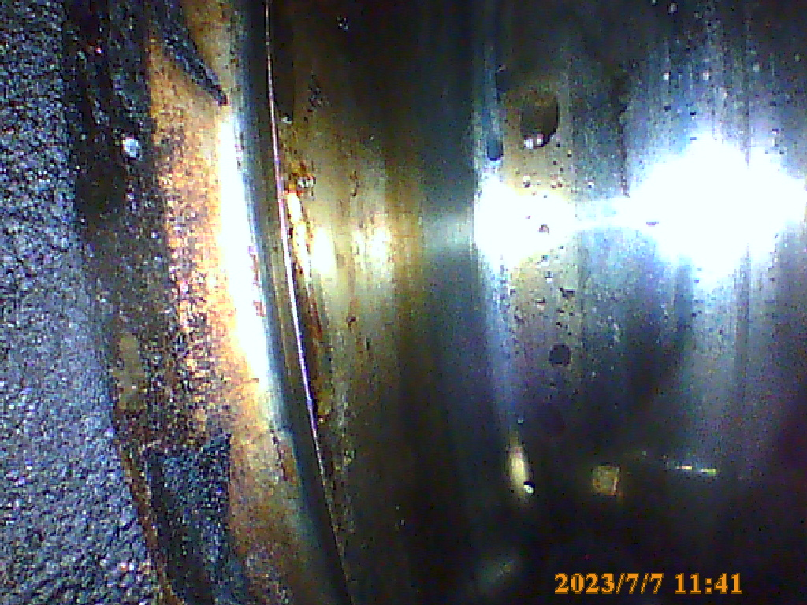
Fig 25 Rotor shaft at CT bearing position adjacent to vibration sensor, carbon build and fluid presence

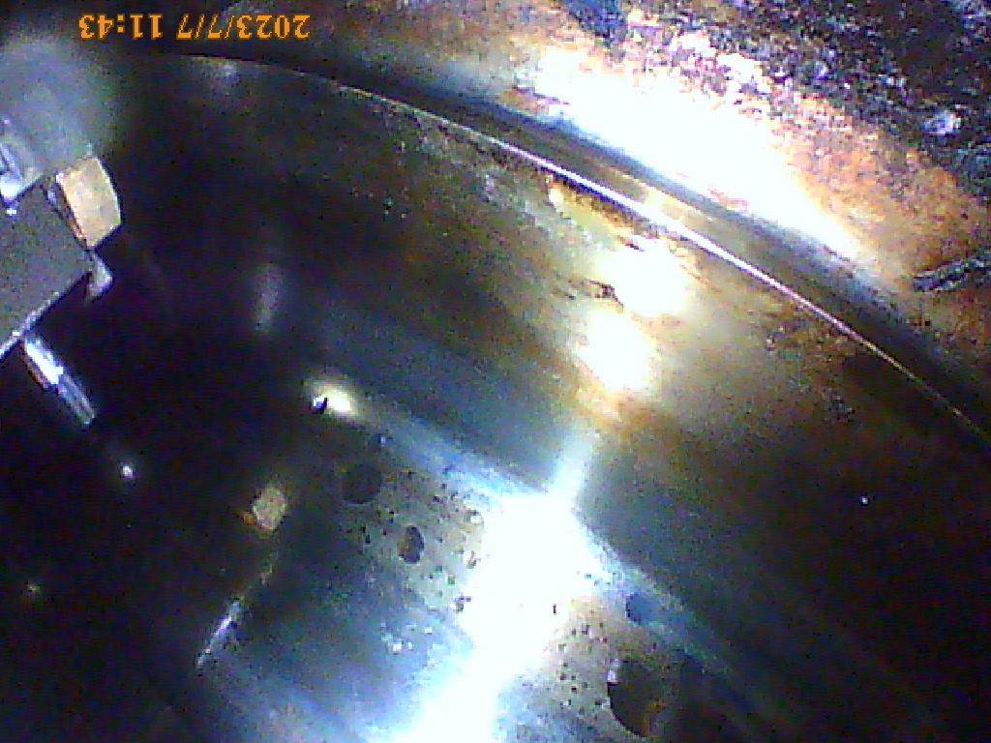
Fig 26 Rotor shaft at CT bearing position adjacent to vibration sensor
The general area of the CT bearing void was not considered as being in “clean condition”, there is some carbon build up in certain areas and it is our opinion, that the fluid droplets visible on the rotor shaft are water droplets, however this may be better established with higher resolution inspection equipment.
The origin of these droplets if water based, may be a result of either condensation or the DC emergency oil pump operating for a period with water contaminated oil pressurizing the lubrication “hot rail” of the machine during period of flooding. The hot rail supplies oil only to bearings at number 2 and number 3 positions.
Additional internal optical images were recorded in other areas of the gas generator using 6mm flexiscope. None revealed presence of water or contamination in the air /gas washed engine casings.
Images Fig 27 & 28 overleaf, show internal images of combustor 4 CT1 nozzle vanes, the hottest area of the machine during operation and also an engine low point with regard to flooding, and in this case an area of the engine fully submerged during the flood event.
As can be seen, both images are consistent in content in terms of condition with no evidence of water or contamination in the more recent image. Unobstructed CT1 Nozzle cooling air holes are visible in both images.
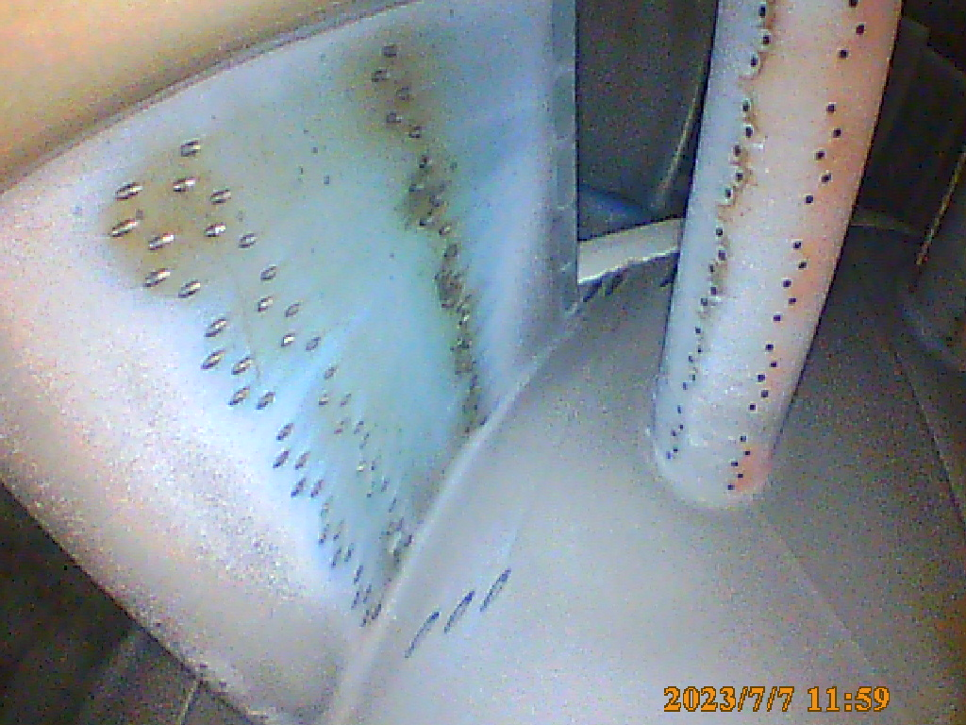
Fig 27- Combustor 4 CT1 Stator vane (engine Low point) July 7 2023 after flood event
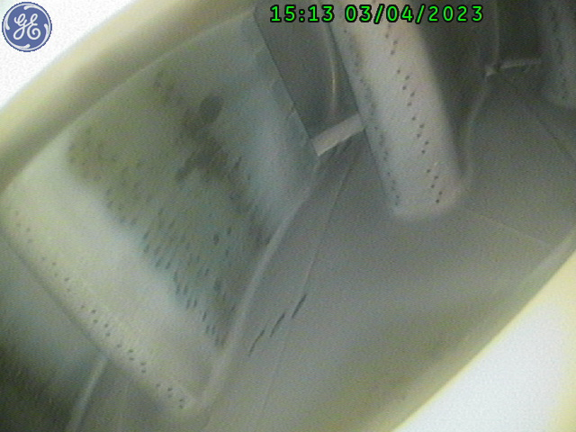
Fig 28- Combustor 4 CT1 Stator vane (engine Low point) CT1 Stator vane April 3 2023 before flood event

Our recommendation for the SGT400 gas generator would be to dismantle the engine to its half casing split line for “cursory preventative inspection”, to physically view the engine internal components and bearings in close detail and to establish actual condition . We would propose to complete this work at our Spain workshop premise 800 km from UNIGRA Plant within the European union.
It should be clearly understood that to carry out an inspection of the gas generator, special engine roll-out equipment resources shall be required as viewed in the reference images below Fig 29&30.
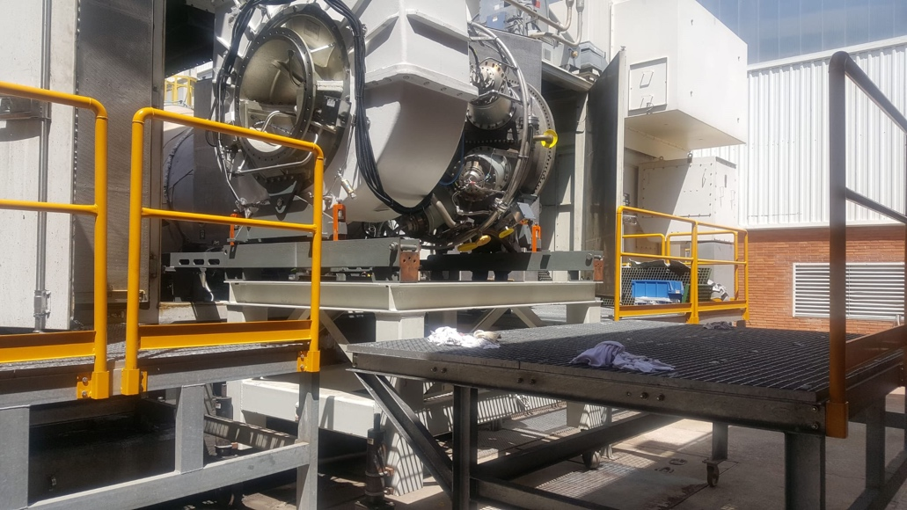
Fig 29 – Typical SGT400 Gas Generator removal gear (Sample image)
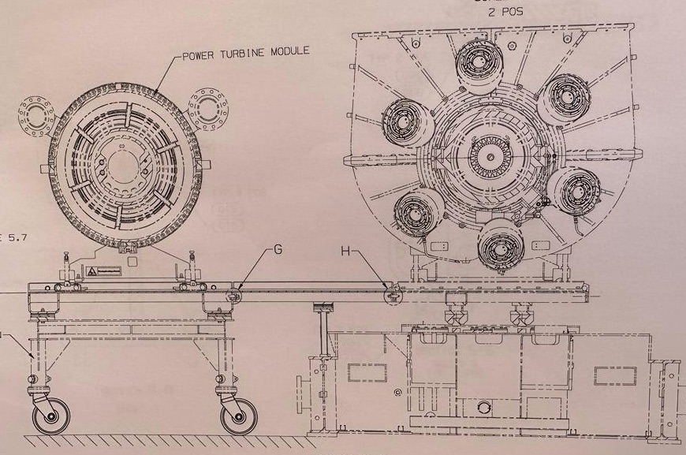
Fig 30- SGT400 Gas Generator removal gear general layout (Sample)
As standard procedure the special maintenance tooling, roll-out gear and engine handling equipment is supplied as an integral part of the gas turbine package equipment contract when purchased and supplied new. This special tooling equipment provides the resource necessary for the customer to perform the recommended scheduled “B” and “D” maintenance inspections according to the manufacturers recommendations as specified in the equipment purchase documentation section 18, and also the ability to respond to unscheduled events as per the present situation at site.
The special tooling equipment resource broadly includes:
- A gas generator stand, in which to place and mount the engine once removed from the package
- Gas Generator & Power Turbine removal roll out equipment to extract the engine from package
- An auxiliary gearbox temporary support pedestal
- Engine lifting beams to facilitate safe equipment handling outside of the package to transport.
- Engine support rollers to facilitate lateral movement of the machine out of its package enclosure
- Power turbine removal gear to facilitate “D” Inspection
- General Maintenance tools of special nature
The UNIGRA engine MW441 has operated for only 8,763 hours, still with 27,000 hours remaining before its scheduled major hot-section maintenance interval. Given to low running hours a completion of a “cursory preventative gas generator inspection” is proposed with the objective to attend to only those areas of the engine demonstrating fault and deemed to require attention, this approach will minimise inspection content, reduce time at workshop, whilst at the same time err toward maintaining minimum cost expenditure.
To complete scheduled maintenance or attend to unscheduled activity effectively, there will be a requirement for the customer to quickly identify and obtain the full package special engine handling tooling content that should be supplied to the UNIGRA site and stored to facilitate maintenance or repair activity. Alternatively, in the absence of said equipment, if the customer is a member of “CX400/SGT400 user group member perhaps it would be feasible to approach a fellow user with a view to loaning tooling equipment on temporary urgent basis.
3.2 Power Turbine
A cursory inspection of the power turbine to main gearbox coupling was completed, the coupling assembly was noted to be dry and clean with no cause for concern.
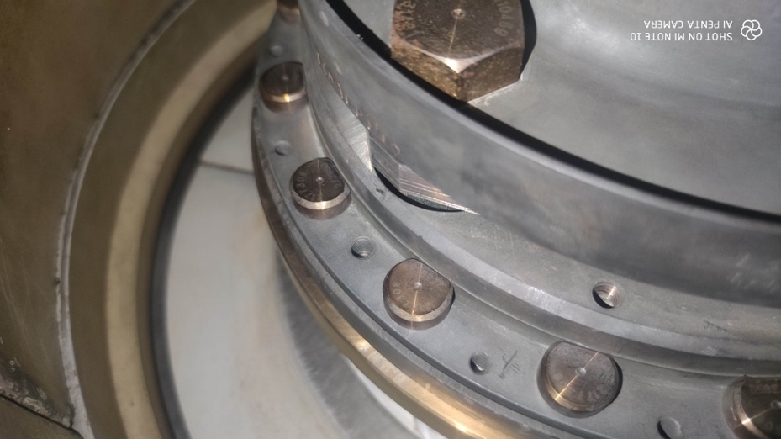
Fig 31- Power turbine output coupling sample Image July 6 2023 post flood event

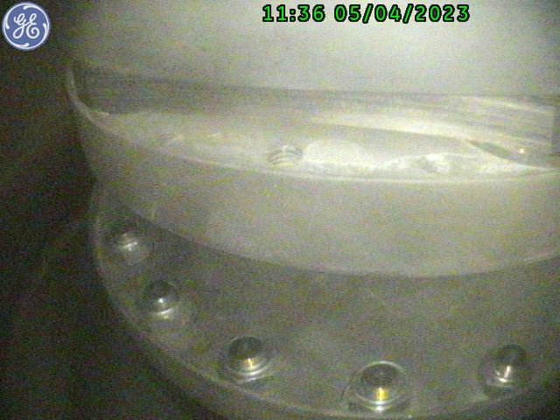
Fig 32- Power turbine output coupling sample OEM Image by endoscope 5 April 2023 prior to flood event
Images 28 &29 are again consistent in content , both images show the PT high speed coupling in good condition, before and after flood event.
The full extent of a potential power turbine intervention would be determined by both additional internal visual inspections at site and in relation to findings observed with the gas generator cursory inspection results identified during dismantling.

4.0 Conclusion / Summary

CX400 Gas Turbine recovery.

A comprehensive survey of the CX400 package was completed during the dates 5-7th July 2023

Based upon our examination of turbine fluid drains and internal images recorded of the core engine and package systems using flexiscope it appears the gas turbine itself has not been subject to severe flood water ingress, this is a clear observation both from our internal optical inspection results and other various inspections completed during survey.

There is concern regarding the CT bearing area of the gas generator and detailed inspection is recommended, this would result in a removal of the gas generator from the package and move to workshop.

In summary, we consider that the existing CX400 equipment is recoverable within a reasonable time frame subject to available deliveries of the necessary spare parts materials and special tooling resources required.

We understand that an internal optical inspection was completed during April 5-7th prior to the UNIGRA site flooding event experienced during May 2023 however, it appears that the equipment requires various aspects of its scheduled “A” Maintenance intervention to be completed and supplier response to the existing flood crisis and commencement of recovery works appear to be stalled.

The control systems both for the turbine itself and the fire and gas protection are significantly affected and will require detailed recovery attention however, we consider all these systems are recoverable utilising the correct resources and reinstatement program.

The following bullet points summarise our near-term initial recommendations and immediate rectification tasks to address the CX400 package necessary to prevent further degradation and to develop an asset recovery plan with the required level of detail.

- Identify and Obtain

- Special maintenance tooling resources required to facilitate scheduled maintenance and gas generator & power turbine removal from package.

- Illustrated Spare parts manual for the SGT400 core engine embedded within the CX400 package, detail currently missing from CX400 package information and specification document.
Timing: Immediate (Customer / Equipment supplier responsibility)

- Complete detailed specific survey of turbine control system by controls engineer specialist as required to improve knowledge of failure, identify full extent of damage by testing and to facilitate development of comprehensive controls system rectification proposal. Expected Site Visit Duration 7 days (2 Engineers present simultaneously)
Timing: Availability of technical personnel, Immediate (Contractor task)

- Complete detailed survey of Fire and Gas protection system by manufacturer representative as required to develop knowledge of full extent of damage and development of comprehensive solution. Expected Site Visit Duration 2 days
Timing: Availability of manufacturer technical personnel. Immediate (OEM / Contractor task)

- Complete cleaning and reinstatement of Alternator cable connection junction boxes and Complete electrical testing of Alternator to confirm integrity . Expected Site Visit Duration 3 days
Timing: Availability of technical personnel. Immediate (Contractor task )

- Complete detailed cleaning of turbine lubrication oil tank and limit corrosion effects,
Timing: Availability of technical personnel. Immediate (Contractor task )

- Review turbine systems devices in conjunction with controls engineer. Expected Site Visit Duration 7-10 days

Timing: Availability of technical personnel. Immediate (Contractor task)

- Complete content of scheduled “A” inspection to address turbine package maintenance due. (this activity may require material procurement if new consumable filtration elements are not available at site) Initiate in conjunction with line 5 , or per material delivery requirement (Contractor)
Timing: per material delivery requirement estimate

- Complete bulk strip inspection for integrity check of turbine gas generator.
Timing: Immediate (Contractor) , subject to line 1. availability of special tooling resources necessary.

Technical resources are available upon request to complete the described tasks 1. thru 7 on immediate timing basis for which a commercial proposal is appended to this report as Annex 1.

In the case Gas Turbine Resources were selected to deliver the overall asset recovery solution, the survey tasks cost incurring our own company staff labour charges would be waived and supported under the overall solution concept agreed.

- Turbo Mach T70 Package

The T70 package is severely affected by flooding , to recover this equipment this would certainly incur a full overhaul of the gas turbine , gearbox and alternator together with all package systems and devices. This route will incur a long and arduous delivery period with the potential costs of recovery being unknown until dismantling inspections have been completed.

Our recommendation would be to source an alternative T70 power generation package with which to replace the present equipment, this is likely to provide a more cost effective and timely solution. GTR have sourced T70 7.5Mw power generation equipment in the range 2.0 - 3.3 Miillion Euro currently available subject to engine type & maintenance status and subject to remaining un sold.

- European Gas Turbine Typhoon Package ( Now Siemens Energy SGT100)

The SGT100 package is severely affected by flooding. To recover this equipment this would certainly incur a full overhaul of the gas turbine , gearbox and alternator together with all package systems control devices as well as all the electrical panels and turbine controls themselves. This route will incur a long and arduous delivery period with the potential costs of recovery being unknown until dismantling inspections and further surveys have been completed.

We understand that this equipment has not operated for approximately 2 years however if the intention is to recover this equipment to functionality, our recommendation would be to source an alternative used SGT100 power generation package with which to use either in its entirety, or to utilise the core components to replace those affected by the flood event. In the interim GTR have sourced a low hours SGT100 DLE package available at 800,000Euro that would form the basis of a bulk replacement the present equipment, this type of activity is likely to provide a more cost effective and timely solution when compared to a bulk repair event.

Confidentiality & Copyright:

This document (and any accompanying drawings/data sheets) contains confidential information and copyright material. It is disclosed in good faith solely for the purpose of evaluating our project and on the understanding that its confidentiality will be properly maintained and safeguarded. Neither it nor any part thereof may be copied or reproduced or used for any purpose other than that for which it is disclosed and, save as reasonably necessary for the proper evaluation of the project concerned, no part thereof may be disclosed to any other persons, without our prior consent in writing. The provisions of this Clause shall survive any termination of this agreement.

Should you have any further questions or require additional information then please do not hesitate to contact the undersigned.

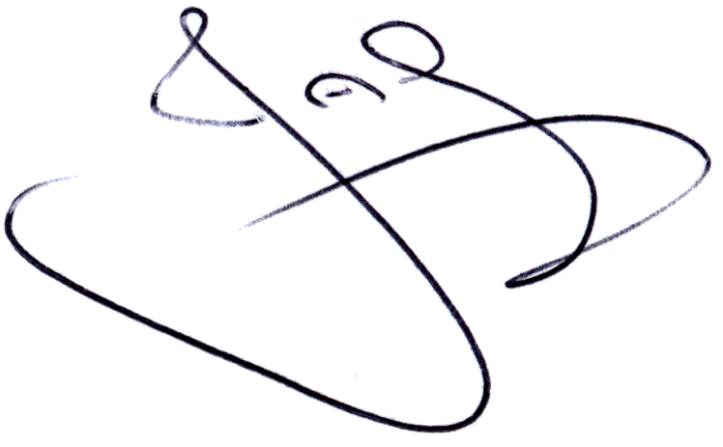
Yours faithfully

John Gamble - Director
Email: john@gasturbineresources.com
Direct Telephone +34 620 194 730.

Enclosures: Annex 1 Commercial proposal for CX400 : Detailed Controls Systems Survey

Annex 1 :Commercial proposal CX400 rectification survey “Controls Systems”:
To complete
- Detailed Controls Systems Survey, incorporating “All Gas Turbine Controls”
- Fire and Gas Protection System Controls and Field Devices
- Gas Turbine Package Control Devices Function Test.
Resources to be mobilised:
1.0 Provision of Gas Turbine Resources Site Manager
Mobilisation , Flights and Travel time -1,200.00 Euro per event
Day rate - 8 Hours per day site attendance 1,400.00 Euro
Additional Hours: 230.00 Euro per hour after 8 hours, or during weekends
Anticipated duration of visit - 7 days working jointly with controls engineer presence (2.0 below)
Total 1,400.00 x 7days + Mobilisation = 11,000.00 Euro

2.0 Provision of CX400 / Allen Bradley / Sematic Controls engineer
Mobilisation , Flights and Travel time -1,800.00 Euro per event
Day rate - 8 Hours per day site attendance 1,650.00 Euro
Additional Hours: 230.00 Euro per hour after 8 hours, or during weekends
Anticipated duration of visit - 7 days
Total – 1,650.00 x 7days +1,800.00 = 13,350 Euro

3.0 Provision of MX FCZ500 Manufacturer’s Representative Controls engineer
Mobilisation , Flights and Travel time 2,100.00 Euro per event
Day rate - 8 Hours per day site attendance 1,850.00 Euro.
Additional Hours: 270.00 per hour after 8 hours or during weekends
Anticipated duration of visit - 2 days
Total 1,700.00 x 2 days + Mobilisation = 5,800 Euro
Maximum estimated CX400 Controls Systems Survey team cost for durations specified 30,150 Euro

Cost will reduce should estimated attendance durations reduce.
Exclusions: Car rental where applicable, local accommodation and meals to be added at cost plus 15%
Services will be implemented after receipt of Principal Customer official Purchase Order.
Purchase Order to be issued to
Gas Turbine Resources SL,
Carrer Llevant 42,
Pol La Carrerada,
Avinyonet del Penedes,
Barcelona 08793 Spain.

Remaining terms for provision of personnel per GTR Provision of Personnel Standard Document terms and conditions, to be provided upon request.

